Online Methodological Appendix

A1. COVID-19 Coping Study (2020-2025)
The data for this paper were collected between April and July 2021, and were part of a larger mixed-methods study called the COVID-19 Coping Study. In April 2020, this study started investigating physical, mental, cognitive, and social health and wellbeing among aging adults in the United States (Kobayashi et al., 2021; Finlay et al., 2022).

Recruitment: For the COVID-19 Coping Study, a multi-frame, non-probability online recruitment strategy was used to enhance coverage of racially and economically diverse populations and geographic locations in April and May 2020. Participants were recruited by snowball sampling through social media including Facebook and Instagram advertisements, organizational mailing lists, the NIH ResearchMatch database, the University of Michigan Health Research database, and word-of-mouth in English and Spanish.

Eligibility: At baseline, participants needed to be at least 55 years old, residing in the United States (including the District of Columbia and Puerto Rico), and able to complete the online survey in English or Spanish.

Longitudinal data collection: Baseline data were collected through a survey designed to take approximately 20 minutes on a computer, tablet or smartphone. The survey was administered through the University of Michigan Qualtrics. Participants in the snowball sampling frame were invited to provide their email addresses if they consented to be contacted for follow-ups.

Participants in the snowball sample who opted in to follow-up contact (n=4,211) were invited via email to complete surveys monthly for one year, and annually for five years. In Spring/Summer 2021, 57 snowball sample participants completed semi-structured interviews by telephone or secure video call (Supplementary Figure 1).

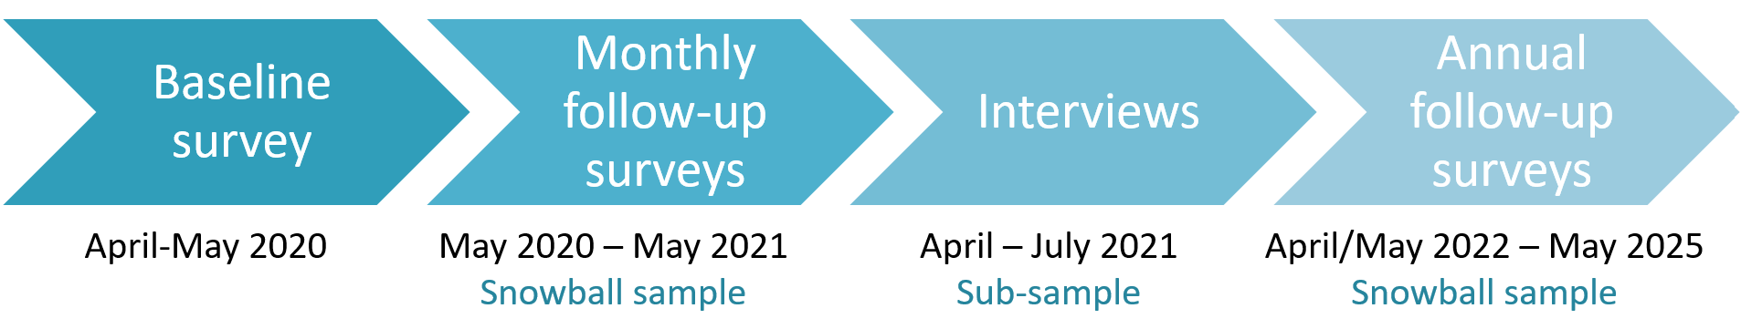
Supplementary Figure 1. COVID-19 Coping Study Timeline

Follow-up surveys: The content of the follow-up surveys varies month-to-month and year-to-year, as certain items are rotated and the content is informed by emergent themes in participant responses to previous surveys, developments in the COVID-19 pandemic, and broader events.

Primary quantitative outcomes of interest include depressive symptoms, anxiety, loneliness, self-rated health, self-rated memory and cognitive health, and life satisfaction. Risk and resilience factors of interest include: physical isolation and forms of face-to-face and virtual social engagement; changes to living circumstances and household composition; changes to employment and income, especially for those adults approaching and working beyond retirement age; COVID-19 incidence, hospitalization and mortality among family and friends; vaccination status; coping strategies and changes in lifestyle behaviors; and neighborhood contextual factors including access to parks and green space, residential segregation, and economic affluence and disadvantage.

Each survey includes 2-5 open-ended long-answer questions. These questions provide an opportunity for in-depth feedback and insights into participants’ personal perceptions, experiences, and wellbeing. Similar to a journal-writing exercise, these large text-box questions facilitate reflection and provide participants with opportunities to write about their daily lives and significant events, and express their feelings. Open-ended questions have probed for wide-ranging topics including significant sources of stress and worry; coping strategies; sources of grief and sadness; stories of joy and distress; impacts on social relationships; neighborhood engagement and perceptions; community impacts; attitudes about social distancing and public health restrictions; vaccine hesitancy; economic impacts; sense of meaning and purpose in life; expectations and plans for the future; and altered daily lifestyles.

All survey questions are available online at: https://sph.umich.edu/covid19copingstudy/.

Study community engagement. To share results and gain feedback from study participants, the COVID-19 Coping Study team distributes quarterly newsletters. These 2-page documents are emailed to all participants who opted in to follow-up contact (by providing an email address at baseline), in addition to anyone who signs up on the study’s public website (https://sph.umich.edu/covid19copingstudy/) or emails the study team directly (covid19copingstudy@umich.edu).

The newsletters include:
- Brief summaries and links to study publications and presentations (e.g., at academic conferences, to community groups, public webinars)
- Study team member introductions, career and life updates (e.g., graduations, new positions, birth announcements), and personal information (e.g., favorite fall recipes, summer activities)
- Research in-focus (summarizing the main content of an academic manuscript or presentation)
- Requests for participant feedback on what questions to include (or not include) in a forthcoming survey

Participants often email the study team in reaction to study newsletters (e.g., to express appreciation or disagreement with specific content), to seek advice on survey administration (e.g., lost login IDs), and share life updates (e.g., self, family, or friends who became sick with or passed away from COVID-19; ongoing health and personal relationship experiences).

A2. Semi-structured interviews: qualitative sub-study (2021)
In order to probe deeper into participants’ nuanced experiences and perspectives, we conducted semi-structured telephone and video call interviews in April-July, 2021. This sub-study was designed to investigate short- and longer-term impacts of the COVID-19 pandemic on perceived physical, mental, and social health and wellbeing.

Recruitment and enrollment: In March-June 2021, study investigators used successive rounds of stratified random sampling (Bhardwaj, 2019) to select and invite COVID-19 Coping Study participants to participate in interviews. 4,211 baseline snowball participants opted in to follow-up contact by providing their emails.

Stratified random sampling is used to focus on a particular stratum from the given population (Bhardwaj, 2019). We purposefully oversampled individuals who identified as male, a racial or ethnic minority, who had less than a college degree, who lived outside of Michigan, and/or who resided in a senior living facility to enhance representation of racially, socioeconomically, and geographically diverse individuals. The goal was to recruit and enroll 60 interview participants in order to have adequate sample size to explore themes by age, sex, race, ethnicity, education, and US geographic region.

JF and ME sent Round 1 email interview invitations to 100 COVID-19 Coping Study participants who were randomly selected from the full snowball participant pool to be representative of the US population aged 55 and older by age, race, ethnicity, gender, and education (using quotas from the American Community Survey [Kobayashi et al., 2021]). Eighteen Round 1 email recipients agreed and successfully scheduled an interview to occur between mid-April to early May, 2021. The majority of Round 1 interviewees were white, female, and highly educated.

In Round 2, we randomly selected individuals from stratified groups in the participant pool who self-identified as over 65 years old, male, non-white, and living outside of Michigan. JF and ME emailed invitations to 100 individuals. Twenty-six Round 2 participants agreed to participate in an interview (the majority of whom identified as male), and scheduled interviews from late April to end of May, 2021. In Round 3, we randomly selected individuals from stratified groups in the participant pool who self-identified as Black, Hispanic, Asian, and American Indian/Alaska Native. We emailed 31 interview invitations. Fifteen individuals agreed to participate and scheduled an interview in June to July, 2021. In Round 4, we randomly selected individuals from a stratified group who identified as residing in a senior living facility to gain an additional perspective on aging in place experiences since the COVID-19 pandemic onset. We sent 2 invitations, and 1 agreed to participate in an interview in July 2021.

After scheduling an interview, 3 participants dropped out due to scheduling conflicts and illness. This yielded a total interview sample of 57 participants.

Compared to the overall COVID-19 Coping Study baseline participants (Kobayashi et al., 2021), the sub-sample of interviewees were on average older (average age of interviewees was 71 vs. 67 years in the full baseline sample). There was greater representation of males (53% of interviewees vs. 36% in the full baseline sample), racial and ethnic minorities (56% vs. 16%), retirees (60% vs. 52%), and individuals living alone (39% vs. 26%).

Semi-structured interview design. The semi-structured interview protocol was designed to take approximately 60 minutes. Questions investigated significant impacts of the COVID-19 pandemic on everyday life; sources of stress; silver linings; relationships; grief and loss; places, spaces and communities; coping strategies; and thoughts about the future (Supplementary Table 1).

Supplementary Table 1. COVID-19 Coping Study Semi-Structured Interview Protocol (2021)

Question | Follow-up probes and prompts
1) Could you tell us about when the COVID-19 pandemic began to affect your life? | - What precautions did you take to keep yourself and those around you safe?  - What aspects of your life have been most affected?  - Have you or anyone close to you had COVID-19? Have you and any household members been vaccinated?
2) Can you tell us about the 2 or 3 biggest sources of stress in your own life over the past year? | - Has that affected your health and wellbeing?  - How?
3) Have you found sources of joy or happiness over the past year? | - Probe for silver linings
4) How, if at all, has the COVID-19 pandemic and its associated restrictions impacted your relationships either positively or negatively? | - E.g., family members, friends, care aides, neighbors, community members, service and care providers  - Have you felt isolated or lonely?  - Have you found other ways to socialize and engage in your community?
5) Did anyone close to you experience significant health problems or pass away in the past year? | - If you feel comfortable sharing, how did you manage that experience?  - Were you able to visit them (in hospital, hospice, at home)?  - Were you included in medical decisions or end of life care discussions?  - Were you able to say goodbye?  - Bereavement process (funeral, family gathering)?  - Have pandemic restrictions impacted your sense of closure?
6) Are/were there any places in particular you’ve missed going to, or services you’ve had troubles accessing given COVID-19 restrictions and closures? | - Where? What activities couldn’t you do?  - What aspects did you miss (e.g., physical health benefit, socialization, entertainment)?  - What did you do instead (if anything)?  - Alternatives?
7) Do you think the culture or general social norms of your neighborhood/community have changed over the past year? | - Have you noticed any broader changes in your state or the country over the past year?  - This could be related to the pandemic or not
8) How are you coping with altered life since the pandemic onset? What about you and your situation has helped or made you resilient? | - Are these ways of coping similar or different from other challenges and difficult times that you have faced in the past?  - Do you think any of your previous life experiences have helped you navigate this tough time?
9) What do you think may look differently about your life going forward? | - Are there any particular practices or new routines that you want to keep up after this acute phase of the pandemic?  - Do you hope society keeps up any particular activities or methods of engagement and support?
10) How have your hopes or expectations for the future changed in the past year? | - How about your expectations or hopes for the future at a broader societal level?  - What are you looking forward to (and not looking forward to) about the future?

Interviewers. JF and ME co-interviewed participants from April-July, 2021. Both interviewers were in early to mid-adulthood, self-identified as female and white, had a college education, have resided in multiple state and country contexts, and live in multi-generational households. The lead interviewer, JF, has multigenerational immediate and extended family members who identify as BIPOC and Hispanic. She also has extensive previous qualitative research experience conducting seated and mobile interviews, focus groups, and ethnography with over 200 socioeconomically and racially diverse older adults.

Data collection timeline. The interviews occurred in April-July, 2021 approximately 1-1.5 years after the US declared COVID-19 a nationwide emergency. During data collection, vaccines had become freely available to older US adults since December 3, 2020 (for those in healthcare and long-term care facilities), December 31 (for those over 80), and early January, 2021 (for those over 65 and with multiple health conditions). In July 2021, the Delta variant became dominant in the US and led to a third wave in cases (Supplementary Figure 2).

Additional key moments and developments during data collection, as noted by the CDC (2023):
- April 2, 2021: The CDC recommended that people who were fully vaccinated against COVID-19 could safely travel at lower-risk to themselves
- April 8, 2021: The CDC Director Dr. Rochelle Walensky released a statement on racism and health during the COVID-19 pandemic: “The disparities seen over the past year were not a result of COVID-19. Instead, the pandemic illuminated inequities that have existed for generations and revealed for all of America a known, but often unaddressed, epidemic impacting public health: racism.”
- April 13, 2021: The CDC and Food and Drug Administration (FDA) issued a joint statement recommending the pause of Johnson & Johnson’s (J&J) COVID-19 vaccine while six cases of rare and serious blood clots in people who received the J&J vaccine were investigated
- April 23, 2021: Following a thorough safety review, the FDA recommended continued use of the J&J vaccine
- July 27, 2021: Amid a Delta variant surge, the CDC released updated masking guidance recommending that everyone in areas with substantial or high transmission wear a mask indoors

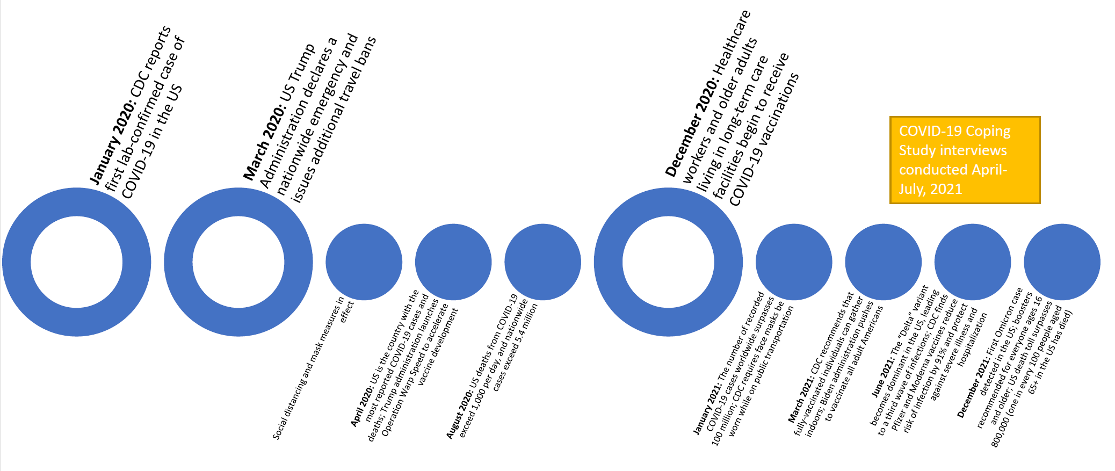
Supplementary Figure 2. COVID-19 Timeline in the US: 2020-2021 (adapted from the CDC [2023] Museum COVID-19 Timeline)

Interview format. The interviewers and interviewees had minimal direct personal contact prior to the interview aside from scheduling the interview and obtaining a digital PDF or mailed signed hard copy of the consent form. Interviews began with unrecorded pleasantries, JF and ME introduced themselves, verbally re-reviewed the consent form, and ensured that the participant had adequate audio/internet connection for recording. The interview was framed as an opportunity to hear more in-depth about their personal experiences, perspectives, and ways of coping since the COVID-19 pandemic onset.

Interviews ranged from 40 to 120 minutes, with an average of approximately 70 minutes. All participants chose to interview alone. JF and ME provided the study email for participants to follow up further (two participants emailed additional thoughts post-interview, which were recorded in their Post-Interview Fieldnotes [Supplementary Table 2]). Summaries of major findings have been shared with participants in the COVID-19 Coping Study community newsletters ‘Research in Focus’ section and directly by email.

47 participants chose to interview by Zoom video call (82.5%), 3 by Zoom voice-only (5.3%), and 7 by phone (12.3%). Participants who chose to interview by telephone cited lack of technological comfort, inadequate internet connectivity for a video call, aversion to Zoom, or health conditions (“more comfortable to take a call lying down”). These participants tended to be older and/or living in rural areas. Participants who chose to interview by Zoom with their cameras off cited the additional comfort and privacy. JF and ME kept their videos on for all Zoom calls so that the participants could see their facial expressions and body language. Bidirectional Zoom video calls often enabled quicker emotional connection to form between the interviewers and interviewee. JF and ME were better able to convey their emotions, see visible participant reactions, and adjust follow-up questions/prompts given participant body language (e.g., if tense or emotional). However, all telephone, non-video, and video mediums enabled trust-building and opportunities for humor, laughter, and expressions of sadness.

Post-interview fieldnotes. During the interview, JF and ME took discreet notes. Within 24 hours of completing the interview, both JF and ME individually completed the Direct Observation Fieldnotes Guide (Supplementary Table 2).

Supplementary Table 2. Post-Interview Fieldnotes
Participant ID number:
Participant pseudonym:
Interviewer report:
Interview date:
Starting time:
Ending time:
Format (e.g., Zoom video call, Zoom voice-only call, telephone call):
People present:
1) Description / impressions of the location observed (if on video)
2) How did the participant handle the Zoom meeting technology? How did they react to any technological challenges?
3) How is/was the participant impacted by COVID-19? Did anything stand out to you?
4) What information, if any, did participants provide about elements of their lives that have changed long-term because of the pandemic?
Probe for external forces pushing change, and self-motivated internal forces of change
5) Content of the interview: summarize main notes from the interview; highlight key words, topics, focus, words or phrases that stand out
6) Impressions: e.g., their opinions, discomfort with certain elements, emotional responses to people, events or technologies
7) Nonverbal behavior: e.g., tone of voice, posture, facial expression, eye movements, forcefulness of speech, body movements, and hand gestures
8) Preliminary Analysis: e.g., interviewer’s questions, tentative hunches, trends in data and emerging patterns, insights, interpretations, beginning analysis, working hypotheses
9) Any other observations:

Reflexive Thematic Analysis. As noted in the Methods section, JF organized all data (interview transcripts and interviewer fieldnotes) in the qualitative analysis software NVivo 12. We chose to use a flexible and inductive approach—reflexive thematic analysis (Braun & Clarke, 2021)—to immerse ourselves in the data, enable new insights to emerge, and analyze participant experiences, perspectives, and meaning-making without imposing pre-existing frameworks or theoretical preconceptions. We followed Braun and Clarke’s (2021) six phases to make sense of the data as embedded within, and surrounded by, bigger sets of values, assumptions, and practices. This involved: (1) data familiarization; (2) data coding; (3) initial theme generation; (4) theme development and review; (5) theme refining, defining, naming; and (6) writing up.

From initial brainstorming of the interview sub-study design to conducting interviews, post-data collection discussions, reflections on coding, and writing, all authors routinely reflected on and discussed their assumptions, expectations, choices, and actions. We each reflected on our role in the practice and process to prioritize subjective, situated, aware, and questioning reflexive research. For example, JF kept reflective journals to jot down thoughts for subsequent reflection, interrogation, and (for some items) group discussion. Journaling helped us reflect, ask critical questions, unpack initial responses, and push deeper.

